Hot Cars

Child dies in car
Tuesday April 9 2002
2 y.o. left alone for thirty minutes
The police are investigating the death of a 2 year old girl. She was spotted by passers-by inside a locked car.  She appeared to be unconscious when she was discovered. The black car had been locked with the windows down by about 4 centimetres.  The car was in the full sun when the child was found. It appears it was parked in the shade, but the Sun had moved and it was no longer in the shade.  The temperature yesterday reached 28°C. However, the temperature inside the car could have reached 50°C. | The manager of the shopping centre broke the window of the car to remove the child.  The ambulance was called and first aid applied. However the girl was dead on arrival at the hospital.  ‘The day was not very warm, but the car was surprisingly hot inside,’ said the manager of the shopping centre.  A police spokesman said that this was the second incident like this in the last week. The previous incident resulted in a young boy going to hospital.  ‘Fortunately he recovered fairly quickly.’ | A government spokesperson said that legislation was being considered to make it illegal to leave children in locked cars.  The Automobile Club warned that there was no safe time to leave children locked in vehicles. Leaving the windows partly open made very little difference.  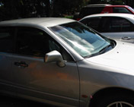

If we are going to help prevent incidents like the one described in the newspaper article 'Child dies in car', we need to better understand what is happening. We need to understand the answers to questions such as:
- Why did the car get so hot on a mild day?
- Would the colour of the car have had an effect on the death of the child?
- What effect did the partly closed windows have?
- How quickly did the temperature in the car change?
- Would tinted windows have helped?
- Would the car have got hot if it was in the shade?

You could investigate scientifically several aspects of the hot cars problem. Your group could choose the effect of one of the following aspects of the problem to investigate:

- the colour of the car
- having the windows open or closed
- tinting on the windows
- being in the shade or in the sun.

Some suggested approaches:

If you are investigating the effect of colour on the rise in temperature, you could get different coloured sheets of thin card. Fold them into identical envelopes (to control the variable of area). Place a thermometer inside each. Then expose each to sunlight. | 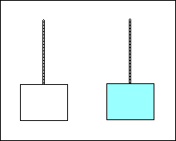
If you are investigating the effect of having windows open or closed, or even partly open, on the rise in temperature, you could use transparent 'take-away' trays. Cut windows of various sizes in the sides. Place a thermometer inside. Then expose each to the sunlight. | 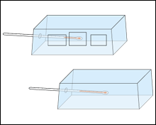
If you are investigating the effect of tinting on the windows on the rise in temperature, you could use inverted transparent take-away trays covered with tinting material. You may be able to get off-cuts from a car tinting firm. Otherwise, you could use clear and blue/green cellophane over the trays. | 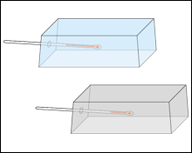
If you are investigating the effect of being in the shade or in the Sun on the rise in temperature, you could use some thin cardboard. Fold it into the shape of envelopes. Place a thermometer inside each. Expose them in the sunlight and in the shade. | 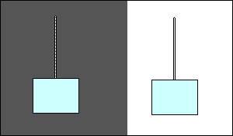
Decide on the approach you will take.

